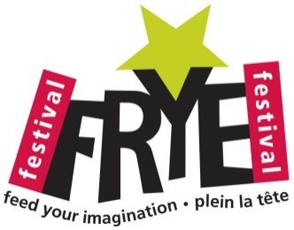
Imagination at Work Form and Submission Criteria
Submission criteria to submit one or several submissions to the Imagination at Work program:
- 8 ½ X 11 sheet of paper, one side only.
- Stories, poems and drawings (accompanied by texts are acceptable).
- All texts will be returned to schools after the Festival
- Please include the following information for each submission:
  - Student’s full name
  - Grade level
  - Teacher’s name
  - School’s name
Please send the texts and drawings by mail (address below) or in person at our office (address below).
Teacher’s name: __________________________
School: __________________________
Grade level:
- Kindergarten
- 1
- 2
- 3
- 4

Frye Festival office:
140 Botsford Street, suite 21 (2nd floor)
Mailing address :
Frye Festival
P.O. Box 26023
Moncton, N. B. E1E 4H9
Nathalie Goguen
Assistant Director
operations@frye.ca
506-859-4389

